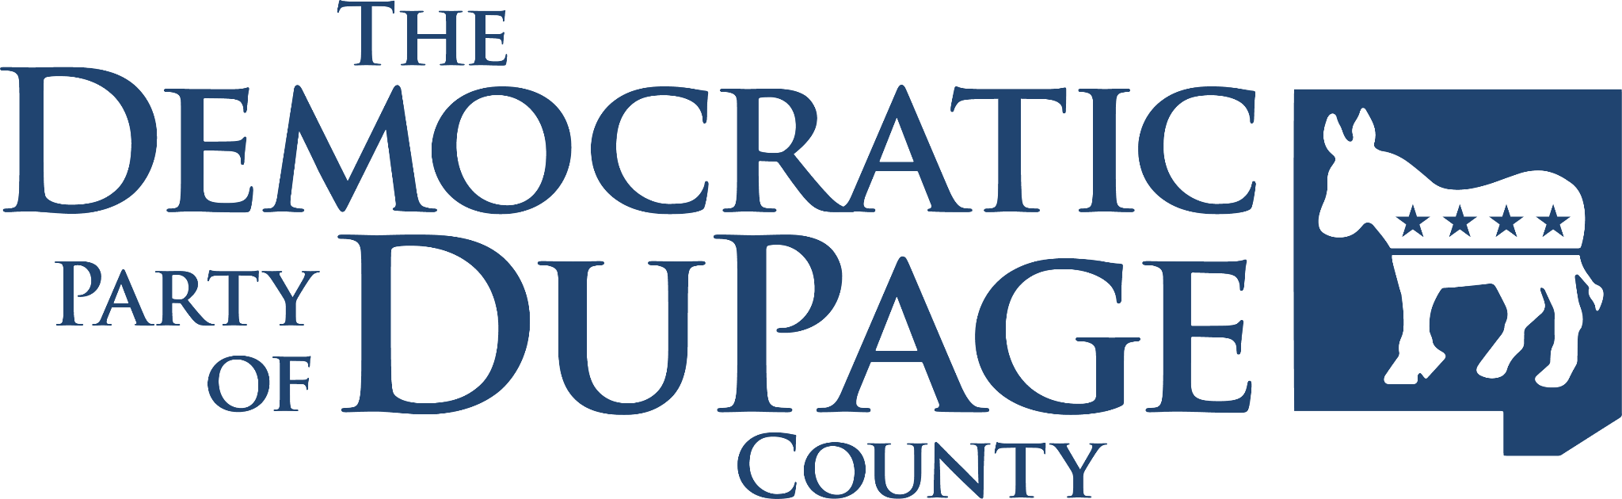

**FOR IMMEDIATE RELEASE:**

Thursday, February 6, 2025

CONTACT:

Ioana Fernandez

[info@dupagedemocrats.com](mailto:info@dupagedemocrats.com)

**Taxpayer Funds Used to Stop Political Opponent**

**VILLA PARK, IL** — York Township Clerk Tony Cuzzone (a Republican) has refused to certify the Democratic candidate for York Township Supervisor, Timothy Murray. No objection to Murray’s candidacy was filed, leaving York Township taxpayers responsible for the legal fees. Among the specious reasons noted in a letter sent to Murray, Cuzzone falsely claims that the Resolution to nominate Murray was not filed within the required timeframe.

Murray has filed a [lawsuit](https://drive.google.com/file/d/1ArPQG3GJELpwWr8J9iMMs-f0U2qhsn1V/view?usp=sharing) against Cuzzone in his capacity as Clerk of York Township. Initial court proceedings will begin on Thursday, February 6 in the 18th Judicial Circuit Court of DuPage County. Murray seeks a preliminary Injunction to have his name printed on the ballot pending resolution of the matter.

Democratic Party Chair of DuPage County, Reid McCollum said, “It should offend every citizen that York Township’s GOP incumbents would force taxpayers to foot the bill for their blatantly partisan scheme. This is clearly an attempt to defeat their opponent by refusing to fulfill the duties of Clerk, rather than allowing voters to decide on April 1.”

###